Assignment-1

Connect and disconnect with login Access

• What happens when you login a non-existent users or username?

o Provide Screenshot and What you understand, explain in short brief?

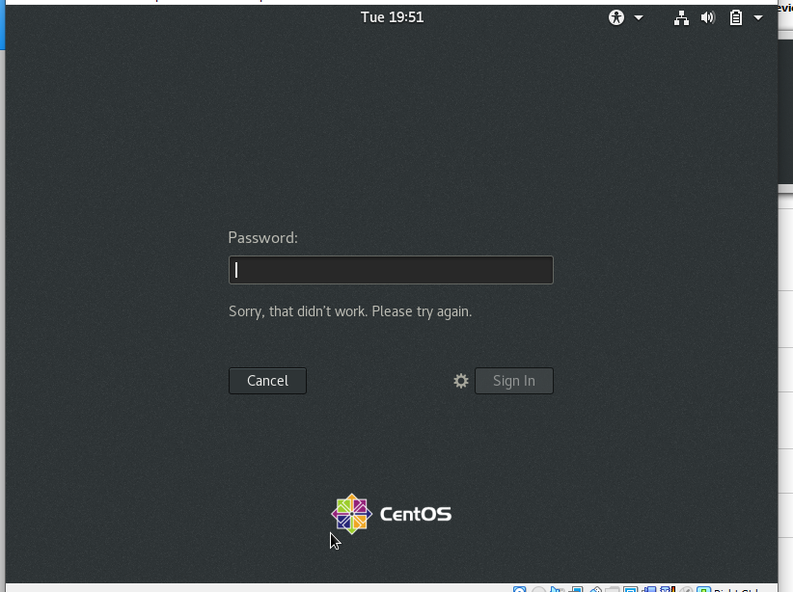

**If the user is not existing it means it is not allowed to sign in and throws an error message.**

Assignment-2

Password changing

· Login into your account and then change password?

o Change your password into ***IneuR0n#42*** and hit the **Enter** key

§ Explain what happen and give screenshot?

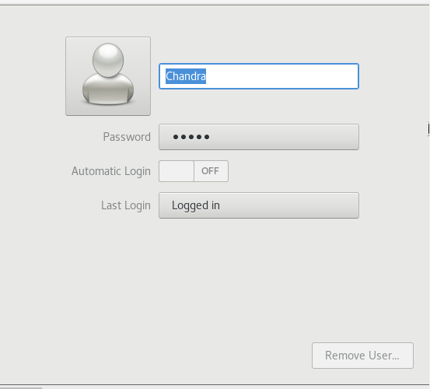

**The system is accepting the new password “*IneuR0n#42*”, and the password also changed.**

o Try again to change password but use like password ***1234*** or ***abcd***

§ Explain what happen and give screenshot?

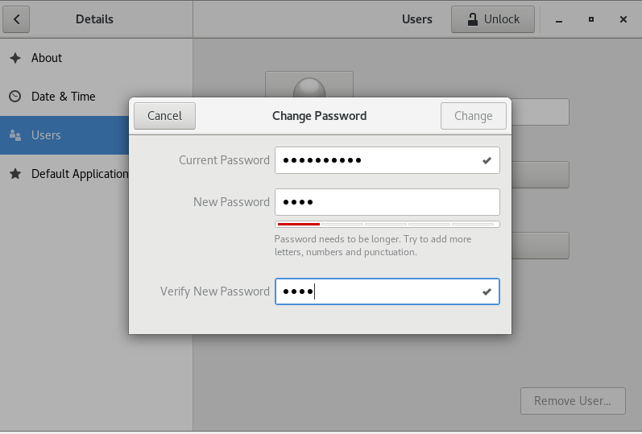

**The system is not allowed to change the password and throws an error message as “password needs to be longer”,because of this the change button will not be enabled.**

o Try again to change password but now don’t use any password just hit **Enter** key

§ Explain what happen and give screenshot?

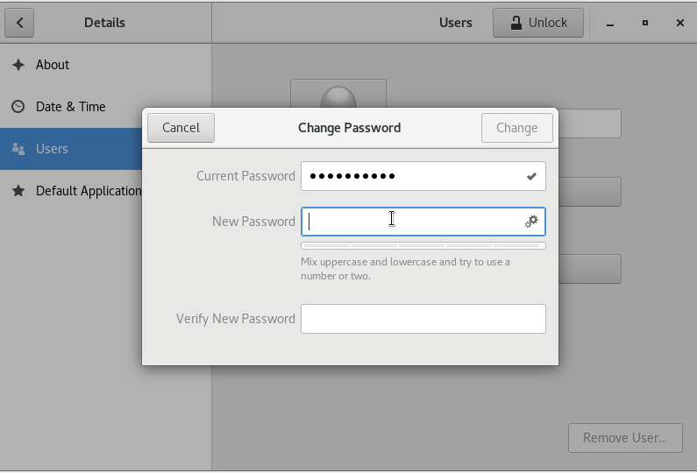

**By Pressing the Enter key without giving any password means,The old password will be the same and nothing will happen.Only cancel action can be done.**

Assignment-3

Working with Directories

· Enter the command **cd /** and then **ls** and then hit **Enter** key

o Take screenshot and explain what output we got?

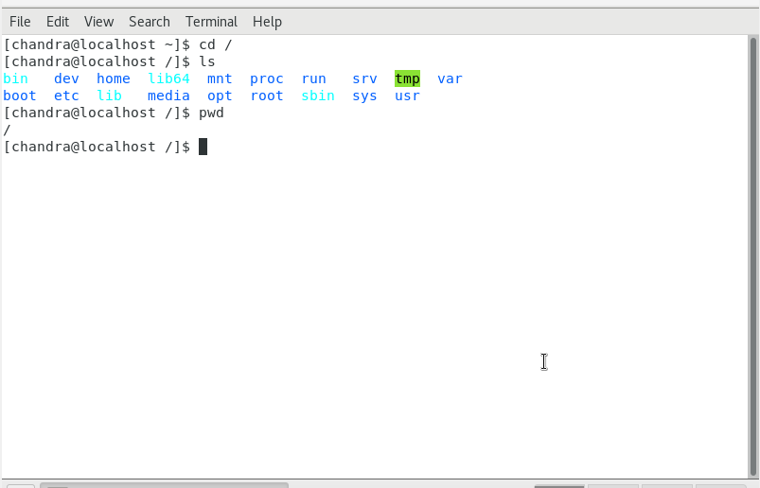

**The cd / this will change directory to the root directory and ls will list the folders in the root directory.**

· Enter the command now **cd /home** and then hit **Enter** key

o Do **ls,** provide screenshot and explain what is **/home** directory used for?

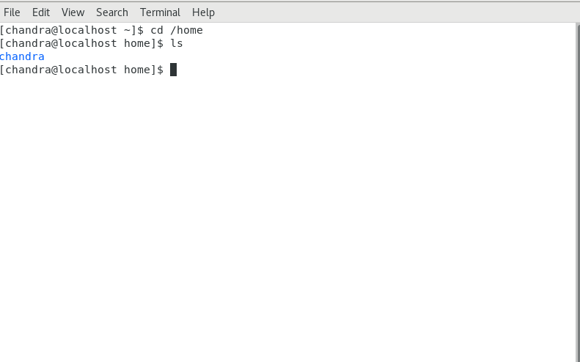

**The command cd /home will change directory to the home directory and by listing it the user directory[chandra] will be inside the home directory.**

· Enter **cd ..** and hit **Enter** key [ *Note: here we have space after cd then use double dot*]

o Check what happen and give screenshot?

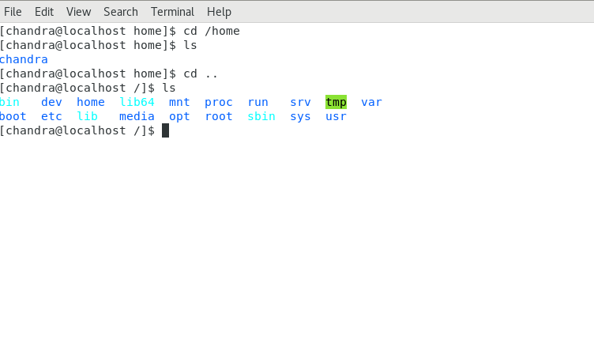

**The cd .. command is used to move to the parent directory from the current directory.In the above screenshot moved from home directory to root directory[/],Here the current directory is home and the parent directory is root.**

· Now enter **cd /var/www/html** and then type **cd** and hit **Enter** key

o Explain what happen and give screenshot?

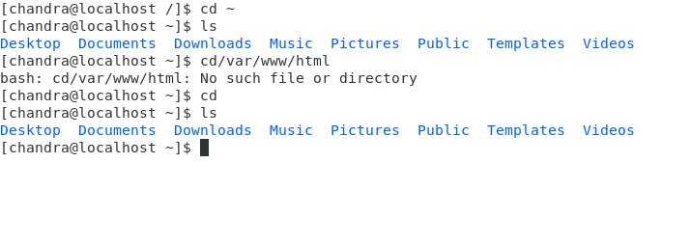

**There is no directory as var,www or html so it will throw an error message as No such file or directory and it will be in the same directory.**

· Now type **cd /root** and then hit **Enter** key

o Do **ls,** check any output we have on screen if yes then take screenshot?

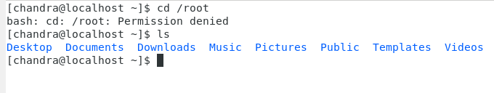

**The cd /root is not allowing me to change the directory it is throwing an error Permission denied.User doesn't have the access for the execute the root.**

Assignment-4

Working with File Listing

· Go to **cd /etc** and type **ls**

o Take screenshot and explain what files you have seeing?

o Take screenshot and explain what different output you found compare to previous command you used?

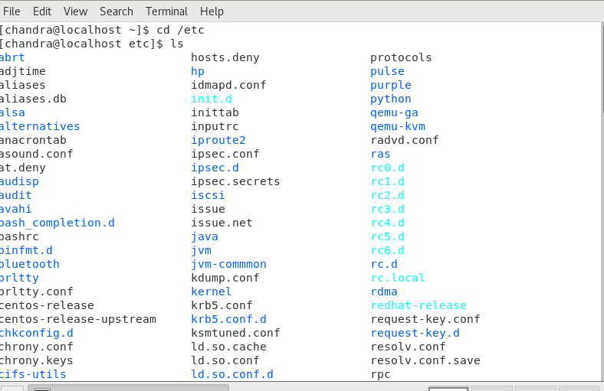

**The / will change directory to root and etc will refer the folder inside the root directory.**

· Then type **ls -al** and hit **Enter** key

o Take screenshot and explain what new file or directory you found?

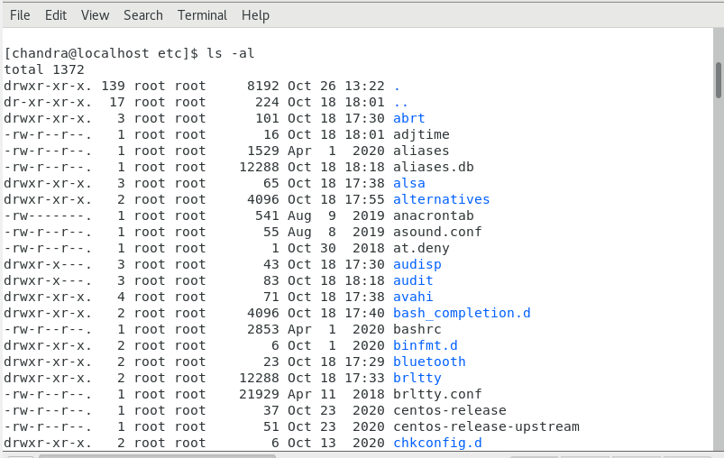

**ls -al command to list files or directories in a table format with extra information including hidden files or directories**

· Then use **ls -i** and hit **Enter** key

o Now see what different output its shows and take a screenshot?

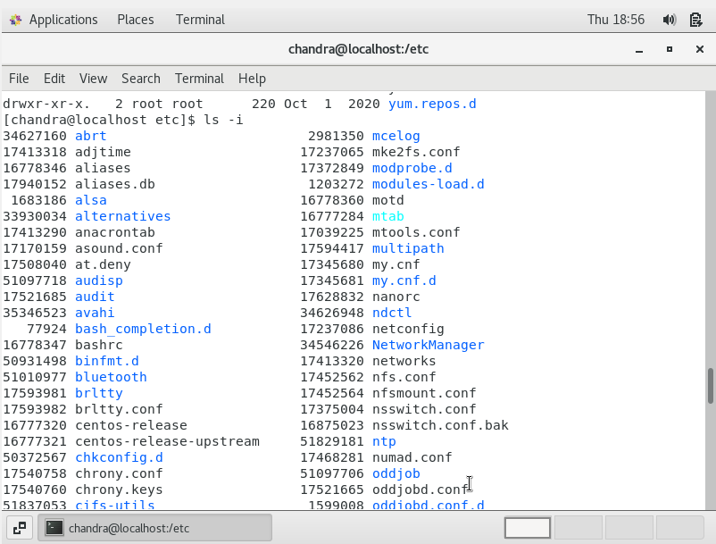

**list file's inode(index) number.**

· Then use **ls –help** and see other options about **ls** command

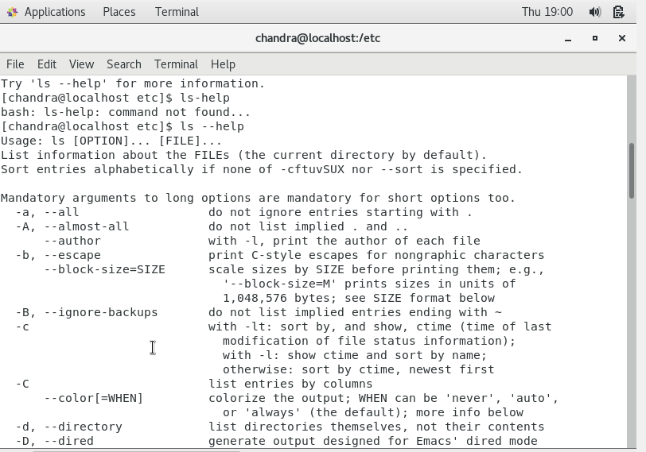

o Explore it and try with other attribute we can use with **ls** command

Assignment-5

Know where you are and where you working

*Here we use* ***pwd, cd and ls*** *as combine task to understand where you working on terminal and how you can switch from one directory to another one.*

· Open terminal after restart the linux

o Check which location you working, type **pwd** and take screenshot

· Now use **cd /var** and hit **Enter** key

o Do **ls,** and see what output comes, give screenshot?

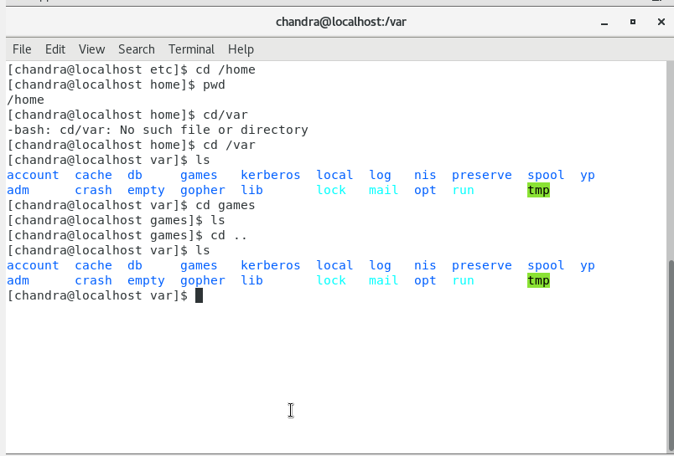

cd ~ : To navigate to home directory

Cd .. : To navigate to the previous directory.

Cd - : display the path of the directory

· Do explore other help options of each command to learn more other things we can do with these commands